# Work Instructions for GitHub commit and Deployment via DevOps

## Purpose

Step by Step process for Direct Deployment from CICD Automation tool.

## Prerequisites



* Need DevOps Solution to be imported in the Instances.
* Microsoft Flow for Dynamics Source Control.
* App need to be registered in Azure environment
* Setup Git Hub Account
* Azure DevOps setup.

## Deployment Configuration

### Create Record in Dynamics Source Control

1. Login to Dynamics 365 instance.
2. Navigate Settings and click on Dynamic Source Control, As shown as in the below image 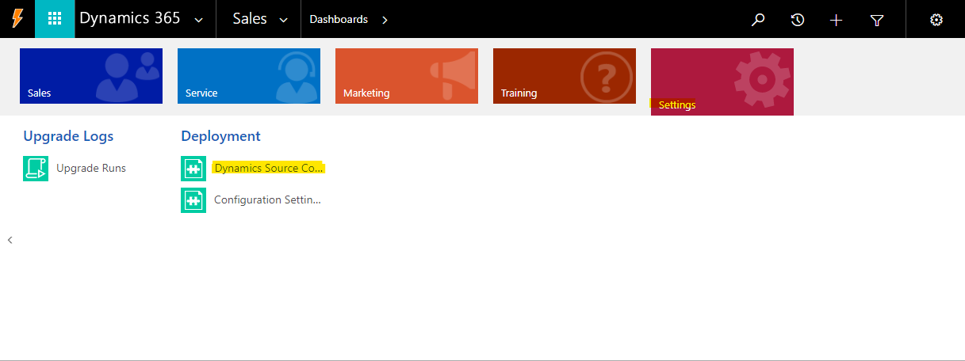
3. Click New button. New Dynamics Source Control will appear as shown below.

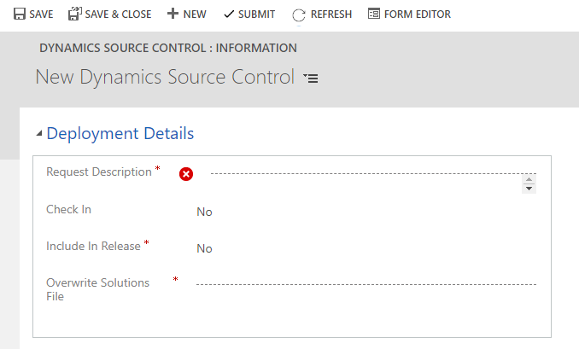

1. For Direct Deployment set below values to respective fields and Click on Save.

|  |  |
| --- | --- |
| **Field** | **Value** |
| Check In | Yes |
| Include In Release | Yes |
| Overwrite Solutions File | Yes |
| Request Description | Please enter detailed description |

### Adding Master and Merge solutions

#### Master Solution

We can add any number of solutions in **Master Solution** grid to deploy in the Target Instance.

Please follow the below steps to add Master Solution record.

1. Navigate to “**Solution Info**” tab, click Add New Master solution.

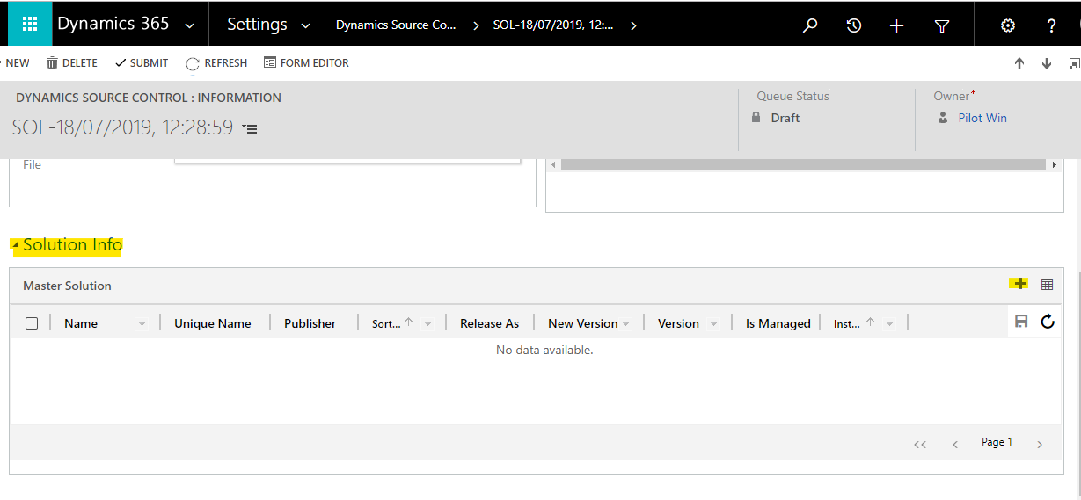

1. New Master Solution record will appear. In **CRM Solution** lookup all unmanaged CRM solutions will populated in this lookup. Please select the solution which you want to deploy in Target. Once you select **CRM Solutions** other fields will be populated automatically.

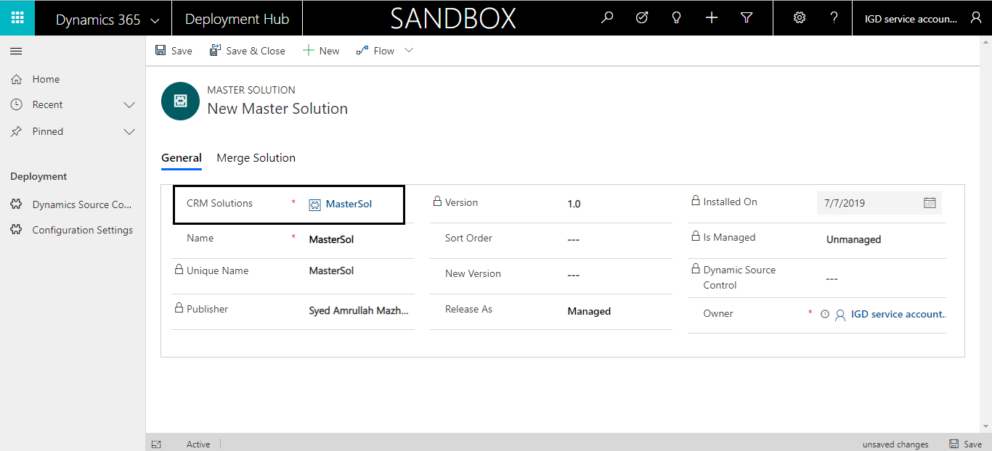

1. Set below fields based on requirement

|  |  |
| --- | --- |
| **Field** | **Description** |
| Release As | Import solution either as managed or unmanaged |
| Sort Order | When there is Multiple Master, Based on Sort Order solution are imported in Target Instance. |

1. Save the record.

#### Merge Solution

To Merge One or More Solutions to One Solution (**Master Solution**) and Deploy the Master Solution to Target Instance. Please follow below steps to Merge Solutions.

1. Go to Merge Solution tab inside master solution record, click Add New Merge Solution.

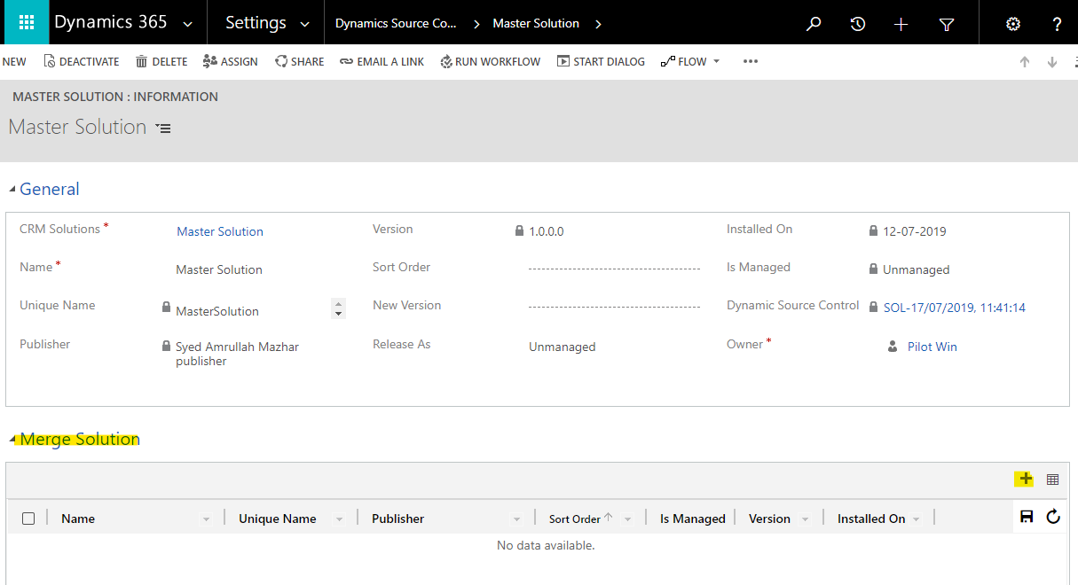

1. In **CRM Solution** lookup all unmanaged CRM solutions will populated in this lookup. Please select the solution which needs to be merged to Master Solution. Once you select **CRM Solutions** other fields will be populated automatically. Merge solution gets associated to master solution.

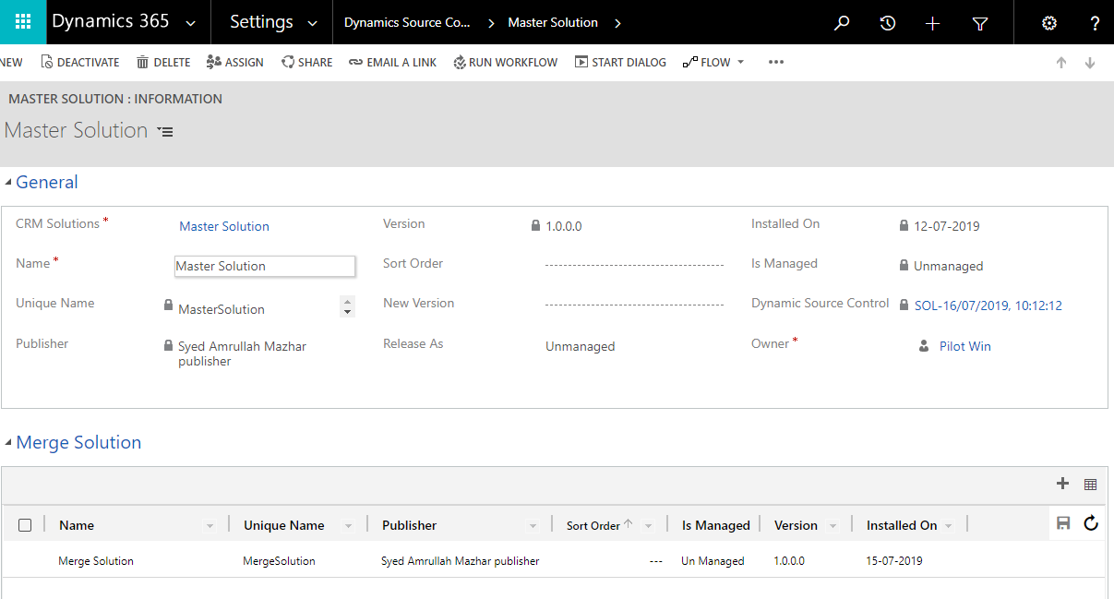

1. Save and close the record.

### Start deployment process.

1. Once all prerequisites are done, click on submit button.

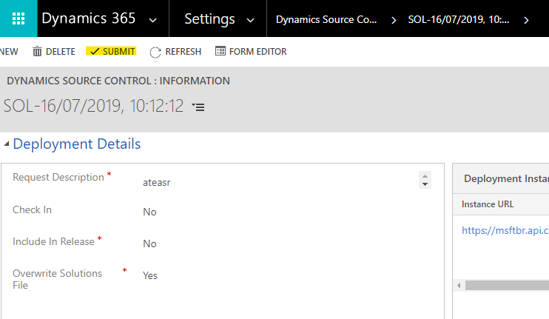

1. After submit button is clicked Queue Status will be changed to Queued and process gets start in background.
2. If in between any pop up appears for credentials provide azure credentials where app registered for solution checker using PowerShell module.

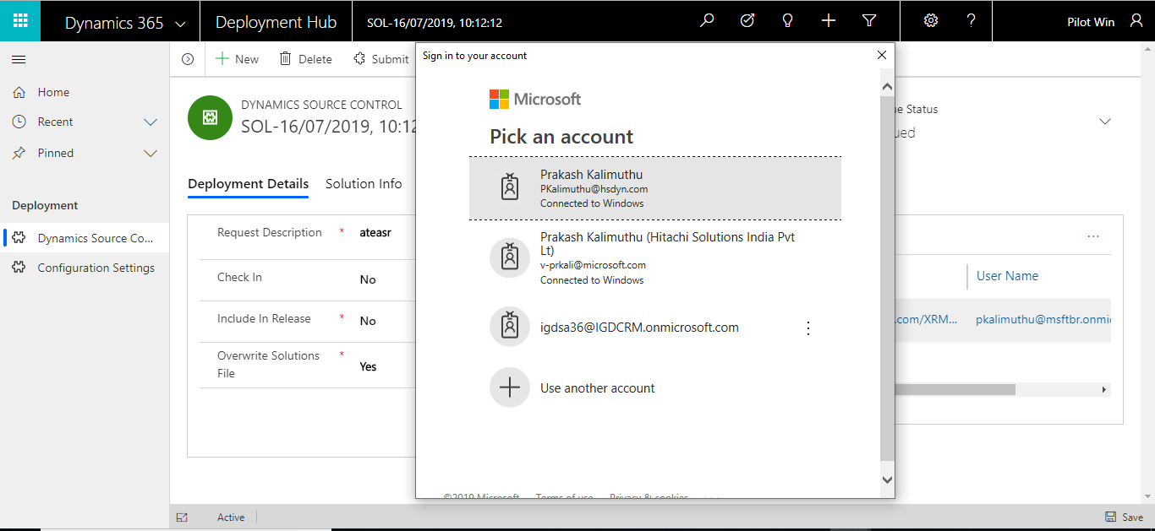

1. To check live status, refer monitoring web jobs.

## Monitoring Web Jobs.

1. In Progress Tab, Web Jobs will be available. Please click on Refresh button to see the Deployment Progress in live.
2. At the end of the process, Logs will be available as Text file in Progress Details section.

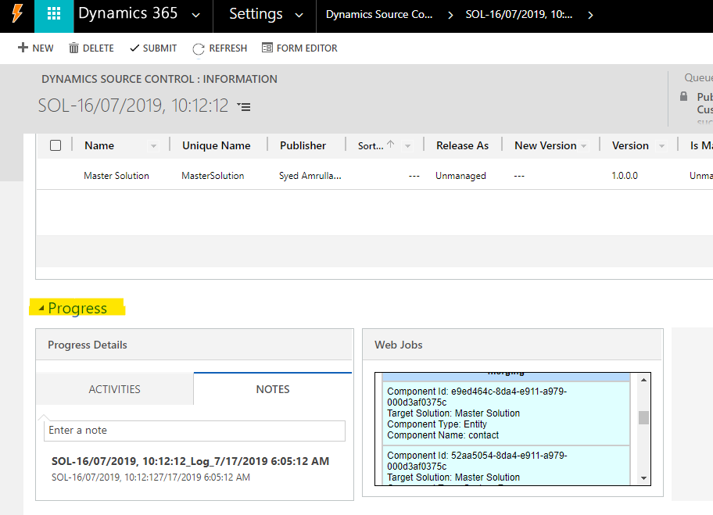

## Deployment via DevOps

* Login to Azure DevOps.
* In your project, navigate to the Pipelines. Then click on Builds and click on the Build Pipeline.
* In the History Section, click on the latest build as shown as below.

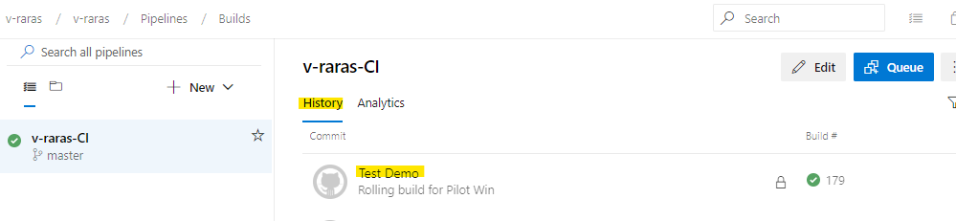

* Once you click on the history, the build details will appear. We can check success and failure details.

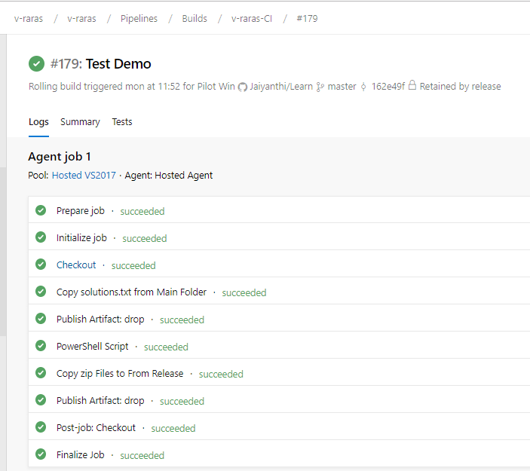

* Click on Releases in Pipeline and click on the Release Pipeline. Navigate to Release section. Now you can see the latest Release.

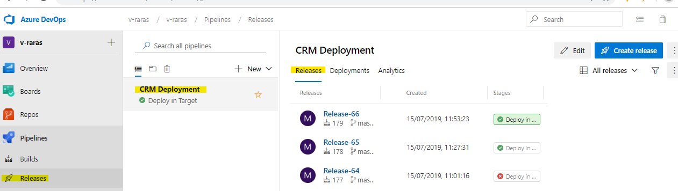

* Release details will appear and now click on Stage for more information.

